A

Project Report

on

**Ride Sharing and CO2 Emission**

Submitted

by

**Ms. Sonal Jain**

Under the Guidance of

**Mr. Mahidhar**



Other Details:

Project Duration: 30 days

Project Sponsor: IBM Smart Bridge

Date: 02.01.2024

**Table of Contents**

1. Introduction
2. Project Objectives
3. Project Scope
4. Project Flow
5. Technical Architecture
6. Features and Functionality
7. Technology Stack
8. Project Implementation
9. Testing and Quality Assurance
10. Project Management
11. Conclusion
12. Future Enhancements

References

**1. Introduction**

The Ride Sharing and CO2 Emissions App is a mobile application designed to promote sustainable transportation by facilitating ride-sharing among users. The app aims to reduce carbon dioxide (CO2) emissions by encouraging people to share rides and make more environmentally friendly transportation choices.

**2. Project Objectives**

* Develop a user-friendly mobile application for both Android and iOS platforms.
* Implement a secure and efficient ride-sharing algorithm.
* Integrate a CO2 emissions tracking system to provide users with real-time data on their environmental impact.
* Encourage users to make sustainable transportation choices by providing incentives and rewards for eco-friendly practices.

**3. Project Scope**

* The app will support user registration and authentication.
* Users can create ride-sharing known as “CARPOOLING” requests or join existing ones.
* A robust algorithm will match users based on their routes, preferences, and schedules.
* The CO2 emissions tracking system will use geolocation data and vehicle information to estimate carbon footprints.
* In-app messaging and notification systems will facilitate communication between users.

**4. Project Flow**

* **Define Problem / Problem Understanding** o Specify the business problem

o Business requirements

o Literature Survey

o Social or Business Impact.

* **Creating a User Interface**
  1. Create a User Interface using HTML, CSS/Bootstrap, and JavaScript, where the user will interact and give input.
* **Database Connection**
  1. Creating necessary Schemas and Tables
  2. Create a Cloud Object Storage to store multimedia data.
* **Flask Application**
  1. Creating python’s flask web framework to connect the front end with the back end services.
* **GitHub**
  1. Pushing all the files to github by using git commands
* **Containerization**
  1. Containerize your application as a docker image and push it into Docker
  2. Push the image to Docker Hub.
* **Kubernetes**

Creating a YAML configuration file

* **Deployment Application in Openshift**
  1. Deploying with Git Repository
  2. Deploying with Docker Image
  3. Deploying with YAML File

**5. Technical Architecture**

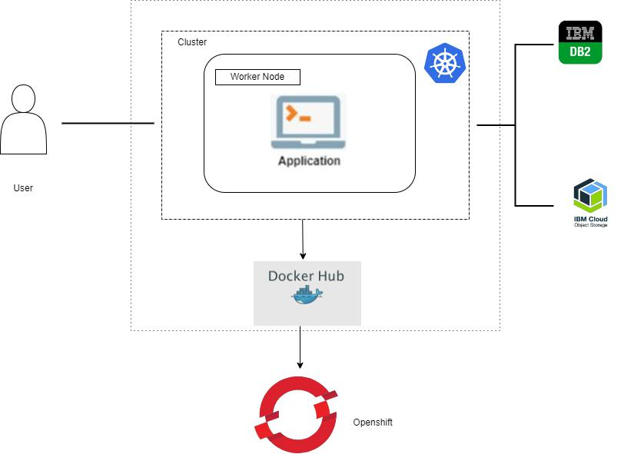

**6. Features and Functionalities**

* User can register and login on the application
* Application has the feature of chatting using chatbot to book the ride and destination
* User Engagement and Incentives: Implement a point system for users based on their eco-friendly choices.

**7. Technology Stack**

Programming Languages: HTML, CSS, Python

Backend: JS with Express for a scalable and robust backend infrastructure.

Database: IBM DB2 for data storage and retrieval.

Cloud Deployment: Integration with IBM Cloud and RedHat Openshift

**8. Project Implementation**

The implementation of project includes the development of both the front-end and back-end components. Security measures are implemented to protect user data and ensure secure file uploads.

Project along with screenshots.

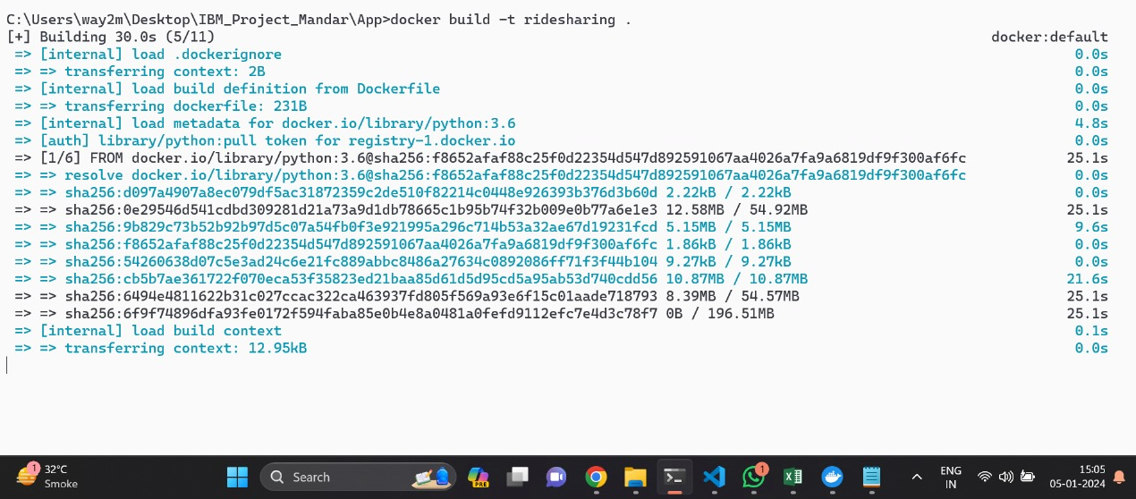

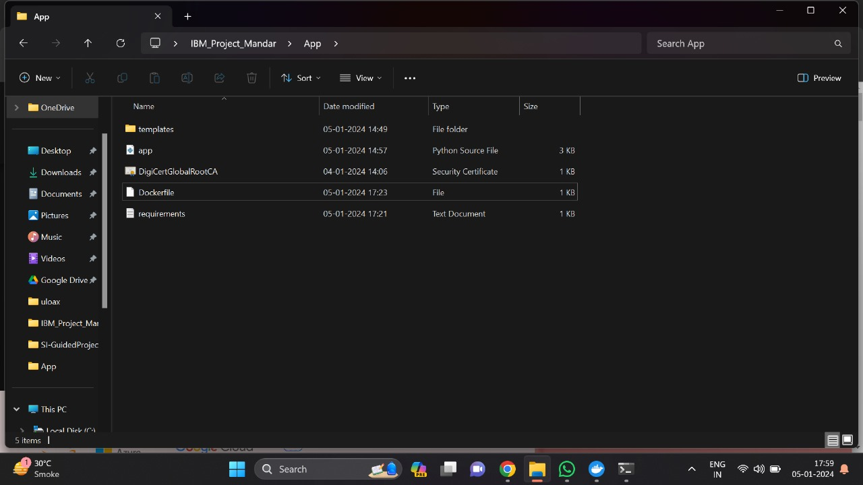

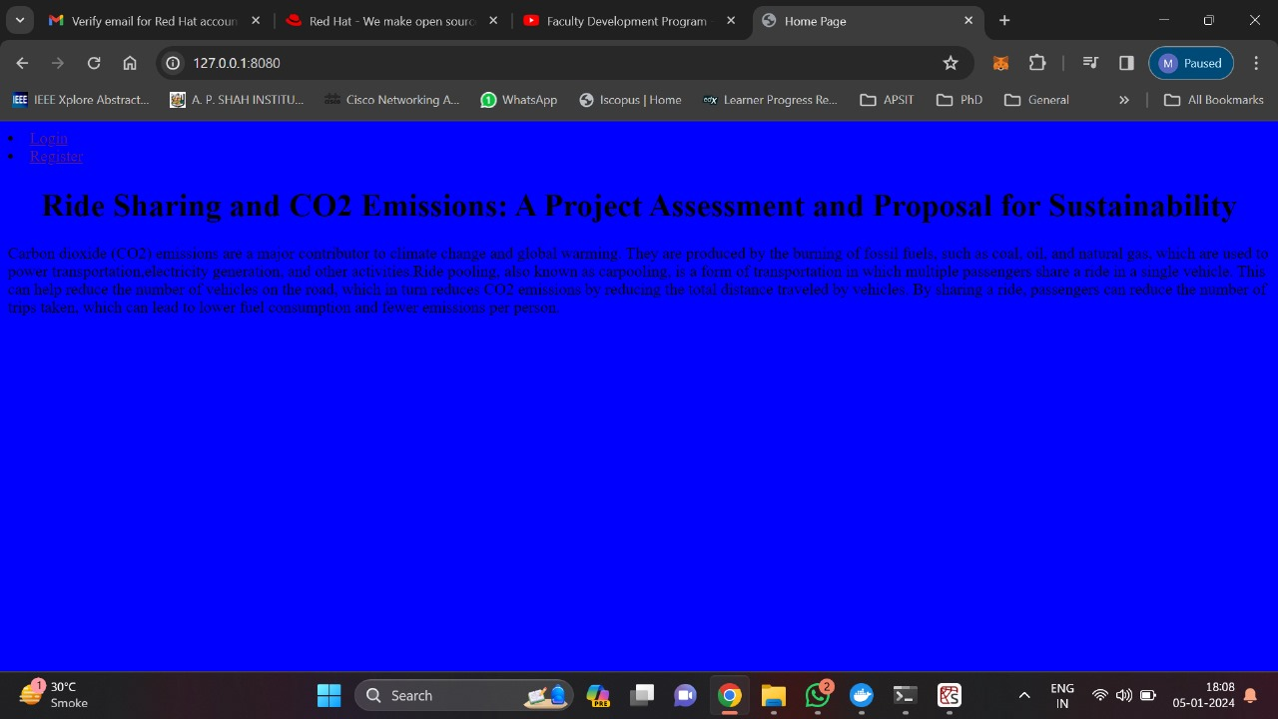

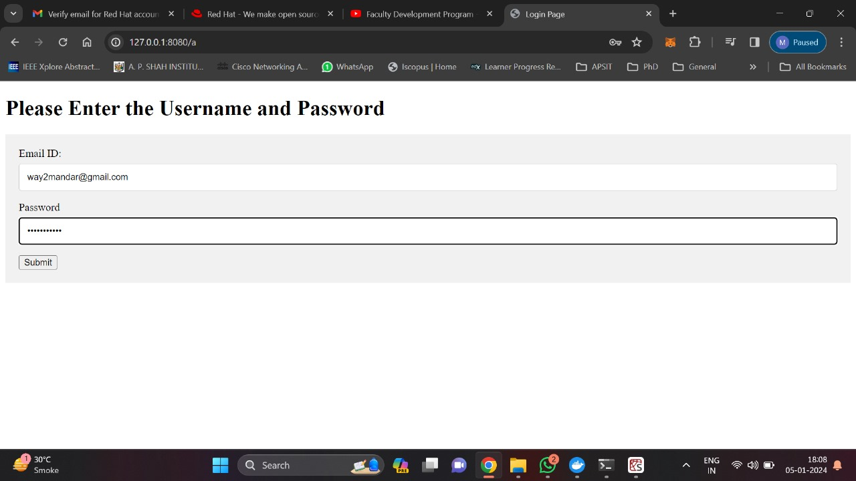

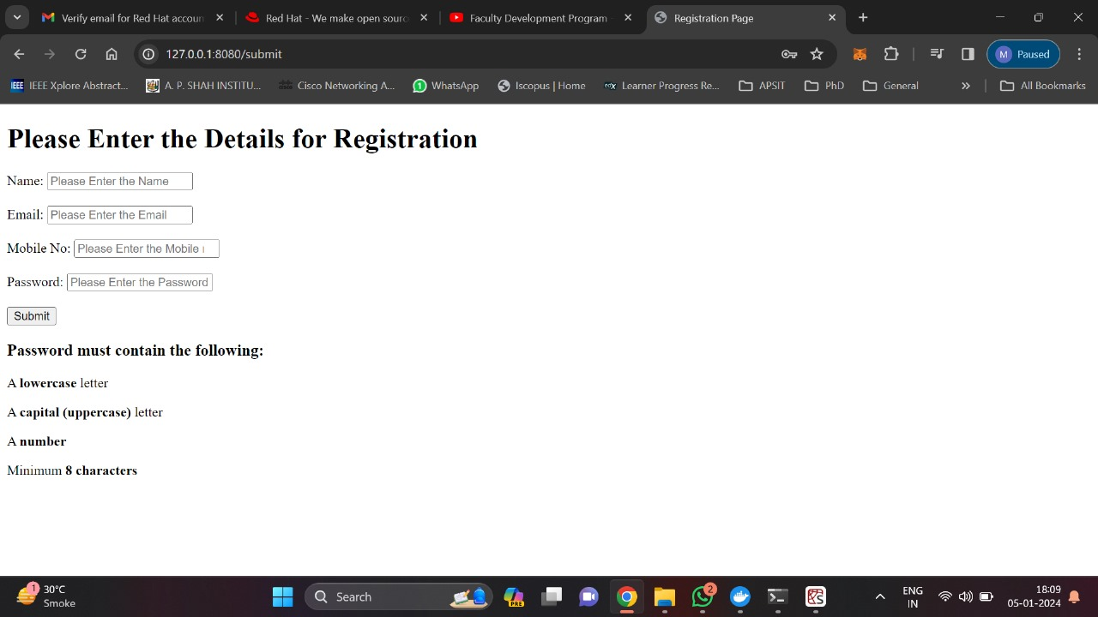

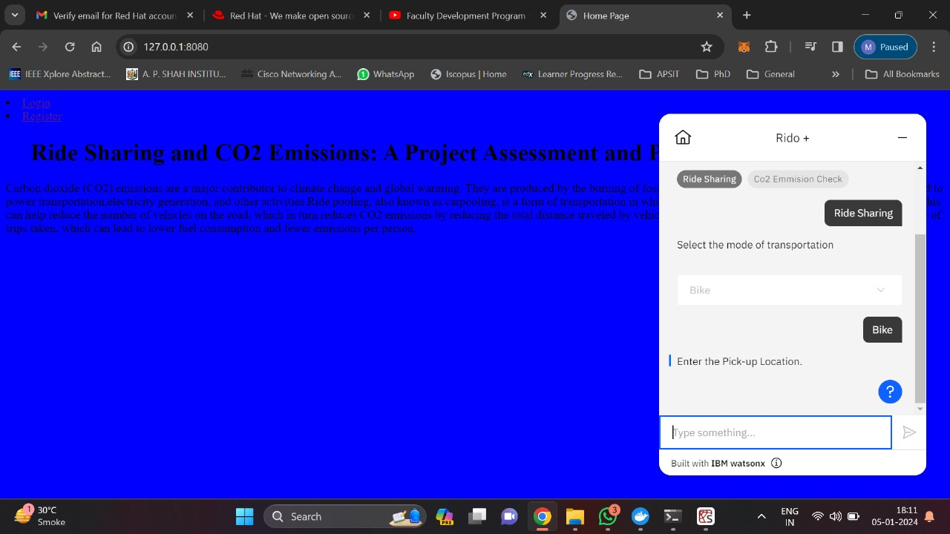

**9. Testing and Quality Assurance**

Thorough testing, including unit testing, integration testing, and user acceptance testing, is conducted to ensure the system's reliability and performance. Quality assurance processes are in place to identify and address any issues.

**10. Project Management**

Project management tools and techniques are employed to track progress, manage tasks, and meet project milestones. Regular communication with stakeholders is maintained to keep them informed of project status.

**11. Conclusion**

The Ride Sharing and CO2 Emissions App aims to revolutionize transportation habits by combining convenience with sustainability. Through effective development, user engagement, and continuous improvement, the app will contribute to reducing carbon footprints and fostering a greener environment.

**12. Future Enhancements**

* Integration with public transportation schedules for more comprehensive route planning.
* Gamification elements to further encourage sustainable practices.
* Partnerships with local businesses for additional incentives.

**References**

<https://www.python.org>

<https://cloud.ibm.com>

<https://w3schools.com>